**UNIT-II**

**TRANSMISSION LINE LOSSES**

Since the power stations are usually spread out geographically, the transmission network losses must be taken into account to achieve true economic dispatch. Network loss is a function of **unit generation**. To calculate network losses, two methods are in general use. One is the penalty factors method and the other is the *B* coefficients method. The latter is commonly used by the power utility industry. In the *B* coefficients method, network losses are expressed as a quadratic function:

$$P_{L}= \sum_{m}{\sum_{n}{P_{m}}}{ B}_{mn}{ P}_{n}$$

where, *Bmn* are constants called *B* coefficients or loss coefficients

[**OPTIMUM GENERATION SCHEDULING**](http://www.eeeguide.com/optimum-generation-scheduling/) **WITH LOSSES:**

From the unit commitment table of a given plant, the fuel cost curve of the plant can be determined in the form of a polynomial of suitable degree by the method of least squares fit. If the transmission losses are neglected, the total system load can be optimally divided among the various generating plants using the equal incremental cost criterion of Eq. (1.10). It is, however, unrealistic to neglect transmission losses particularly when long distance transmission of power is involved.

The transmission losses may vary from 5 to 15% of the total load, and therefore, it is essential to account for losses while developing an economic load dispatch policy. It is obvious that when losses are present, we can no longer use the simple ‘**equal incremental cost’** criterion.

To illustrate the point, consider a two-bus system with identical generators at each bus (i.e. the same IC curves). Assume that the load is located near plant 1 and plant 2 has to deliver power via a lossy line. Equal incremental cost criterion would dictate that each plant should carry half the total load; while it is obvious in this case that the plant 1 should carry a greater share of the load demand thereby reducing transmission losses.

In this section, we shall investigate how the load should be shared among various plants, when line losses are accounted for.

The objective is to minimize the overall cost of generation



at any time under equality constraint of meeting the load demand with transmission loss, i.e.

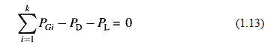

Where

k = total number of generating plants

PGi = generation of ith plant

PD = sum of load demand at all buses (system load demand)

PL = total system transmission loss

To solve the problem, we write the Lagrangian as



It will be shown later in this section that, if the power factor of load at each bus is assumed to remain constant, the system loss PL can be shown to be a function of active power generation at each plant, i.e.

**

Thus in the optimization problem posed above, PGi (i = 1, 2, …, k) are the only control variables.

For optimum real power dispatch,





Rearranging Eq. (1.16) and recognizing that changing the output of only one plant can affect the cost at only that plant, we have



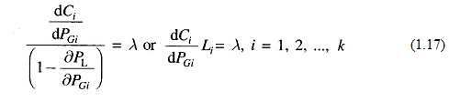

where

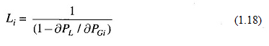

is called the penalty factor of the i th plant.



The Lagrangian multiplier λ is in rupees per megawatt-hour, when fuel cost is in rupees per hour. Equation (1.17) implies that minimum fuel cost is obtained, when the incremental fuel cost of each plant multiplied by its penalty factor is the same for all the plants.

The (k+1) variables (PG1, PG2,… PGK, λ can be obtained from k optimal dispatch Eq. (1.17) together with the power balance Eq. (1.13). The partial derivative δPL/δPGi is referred to as the **incremental transmission loss (ITL)i**, associated with the ith generating plant.

Equation (1.17) can also be written in the alternative form



This equation is referred to as the **exact coordination equation.**

**REPRESENTATION OF TRANSMISSION LOSS BY B-COEFFICIENTS:**

One of the most important, simple but approximate, methods of expressing transmission loss as a function of generator powers is through B-coefficients. This method is reasonably adequate for treatment of loss coordination in economic scheduling of load between plants. The general form of the loss formula (derived later in this section) using B-coefficients is

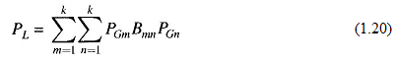

[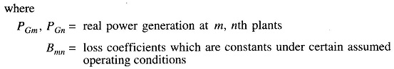](http://www.eeeguide.com/wp-content/uploads/2016/12/Optimum-Generation-Scheduling-9.jpg)

If PGs are in megawatts, Bmn are in reciprocal of megawatts. Computations, of course, may be carried out in per unit.

Equation (1.20) for transmission loss may be written in the matrix form as



Where

[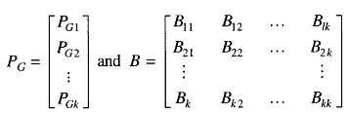](http://www.eeeguide.com/wp-content/uploads/2016/12/Optimum-Generation-Scheduling-11.jpg)

It may be noted that B is a symmetric matrix.

For a three plant system, we can write the expression for loss as



With the system power loss model as per Eq. (1.20), we can now write

$\frac{∂P_{L}}{∂P_{Gi}}=\frac{∂}{∂P_{Gi}}$ $\left[\sum_{\begin{aligned} \\ m=1 \\ \end{aligned}}^{k}{\sum_{\begin{aligned} \\ n=1 \\ \end{aligned}}^{k}{P_{Gm}}B_{mn}P_{Gn}}\right]$

$$=\frac{∂}{∂P_{Gi}}\left[\sum_{\begin{aligned}n=1 \\ \end{aligned}}^{k}{P_{Gi}}B_{in}P_{Gn}+\sum_{\begin{aligned}m=1 \\ m≠i\end{aligned}}^{k}{\sum_{\begin{aligned}n=1 \\ \end{aligned}}^{k}{P_{Gm}}B_{mn}P_{Gn}}\right]$$

$$=\frac{∂}{∂P_{Gi}}\left[P_{Gi}B_{ii}P_{Gi}+ \sum_{\begin{aligned}n=1 \\ n≠i\end{aligned}}^{k}{P_{Gi}}B_{in}P_{Gn}+\sum_{\begin{aligned}m=1 \\ m≠i\end{aligned}}^{k}{P_{Gm}}B_{mi}P_{Gi}+\sum_{\begin{aligned}m=1 \\ m≠i\end{aligned}}^{k}{\sum_{\begin{aligned}n=1 \\ n≠i\end{aligned}}^{k}{P_{Gm}}B_{mn}P_{Gn}}\right]$$

$$=2B_{ii}P_{Gi}+\sum_{\begin{aligned}n=1 \\ n≠i\end{aligned}}^{k}{}B_{in}P_{Gn}+\sum_{\begin{aligned}m=1 \\ m≠i\end{aligned}}^{k}{P_{Gm}}B_{mi}+0$$

$$\frac{∂P_{L}}{∂P_{Gi}}=2B_{ii}P_{Gi}+\sum_{\begin{aligned}n=1 \\ n≠i\end{aligned}}^{k}{}B_{in}P_{Gn}+\sum_{\begin{aligned}m=1 \\ m≠i\end{aligned}}^{k}{B_{im}P_{Gm}}$$

$$\frac{∂P_{L}}{∂P_{Gi}}=2B_{ii}P_{Gi}+\sum_{\begin{aligned}j=1 \\ j≠i\end{aligned}}^{k}{}B_{ij}P_{Gj}+\sum_{\begin{aligned}j=1 \\ j≠i\end{aligned}}^{k}{B_{ij}P_{Gj}}$$

Bij = Bji

Assuming quadratic plant cost curves as

[Optimum Generation Scheduling](http://www.eeeguide.com/wp-content/uploads/2016/12/Optimum-Generation-Scheduling-16.jpg)

We obtain the incremental cost as



Substituting $\frac{∂P_{L}}{∂P_{Gi}}$ and dCi/dPGi from above equation (1.24),(1.25) in the coordination **Eq.** (1.17), we have

$\frac{\frac{dC_{i}}{dP_{Gi}}}{(1- \frac{∂P_{L}}{∂P_{Gi}})}= τ$ $\frac{\frac{dC_{i}}{dP_{Gi}}}{(1- \frac{∂P_{L}}{∂P_{Gi}})}= τ$…….. (1.17)

$τ- τ\frac{∂P_{L}}{∂P_{Gi}}=\frac{dC_{i}}{dP_{Gi}}$ $τ- τ\frac{∂P_{L}}{∂P_{Gi}}=\frac{dC_{i}}{dP_{Gi}}$

$$τ- τ\left(2\sum_{\begin{aligned}j=1 \\ \end{aligned}}^{k}{B_{ij}P_{Gj}}\right)=a_{i}P_{Gi}+b_{i}$$

$$τ=a_{i}P_{Gi}+b_{i}+τ\sum_{\begin{aligned}j=1 \\ \end{aligned}}^{k}{2B_{ij}P_{Gj}} …….(1.26)τ=a_{i}P_{Gi}+b_{i}+τ\left(2B_{ii }P_{Gi}\right)+τ\sum_{\begin{aligned}j=1 \\ j≠i \\ \end{aligned}}^{k}{2B_{ij}P_{Gj}}$$

Collecting all terms of PGi and solving for PGi, we obtain

- = (

Divide both numerator and denominator with $τ$



$P_{Gi}=\frac{1-\frac{b_{i}}{λ}-\sum_{\begin{aligned}j=1 \\ j≠i\end{aligned}}^{k}{2B_{ij}}P_{Gj}}{\frac{a_{i}}{λ}+2B_{ii}}$ $P_{Gi}=\frac{1-\frac{b_{i}}{λ}-\sum_{\begin{aligned}j=1 \\ j≠i\end{aligned}}^{k}{2B_{ij}}2P_{Gj}}{\frac{a_{i}}{λ}+2B_{ii}}$, i=1,2,3,…..,k …..(1.27)

for any particular value of λ, Eq. (1.27) can be solved iteratively by assuming initial values of PGis(a convenient choice is PGi= 0; i = 1, 2, …, k). Iterations are stopped when PGis converge within specified accuracy.

Equation (1.27) along with the [power balance](http://www.eeeonline.org) Eq. (1.13) for a particular load demand PD are solved iteratively on the following lines:

**ALGORITHM FOR ECONOMIC LOAD DISPATCH PROBLEM USING LAMBDA ITERATION METHOD CONSIDERING LOSSES**

The detailed Algorithm for solving the economic load dispatch problem

using lambda iteration method is given below

**Step 1:** Read data namely cost-coefficients, B-coefficients, PG limits and power

demand.

**Step 2:** Make an initial guess λand Δλfor the Lagrange multiplier.

**Step 3:** Calculate the generations based on equal incremental production cost.

**Step 4:** Calculate the generations at all buses using the equation

$$P_{Gi}=\frac{1-\frac{b_{i}}{λ}-\sum_{\begin{aligned}j=1 \\ j≠i\end{aligned}}^{k}{2B_{ij}}2P_{Gj}}{\frac{a_{i}}{λ}+2B_{ii}}$$

**Step 5:** Check the generation limits and impose the limits in case of violation.

If PGi > PGi,max, set PGi = PGi,max

If PGi < PGi,min, set PGi = PGi,min

**Step 6:** Check if the difference in power at all generator buses between two

Consecutive iterations is less than a pre-specified value. If not, go back

to step 3.

**Step 7:** Calculate the loss using the relation

$P_{L}=\sum_{m=1}^{k}{\left(\sum_{n=1}^{k}{P_{Gm}B_{mn}P_{Gn}}\right)}$

$\sum_{\begin{aligned} \\ m=1 \\ \end{aligned}}^{k}{\sum_{\begin{aligned} \\ n=1 \\ \end{aligned}}^{k}{P_{Gm}}B_{mn}P_{Gn}}$ And calculate

$$ΔP=\left|\left(\sum{P_{G}}\right)-P_{L}-P_{D}\right|$$

**Step 8:** Check if *ΔP* is less than є (a specified value)

If yes, stop calculation and calculate cost of generation with these values

of powers. Otherwise, go to step 9.

**Step 9:** Increase λ by Δλ (a suitable step size); if *ΔP* < 0 or

Decrease λ by Δλ (a suitable step size); if *ΔP* > 0

and repeat from step 4.

**1.9** [**DERIVATION OF TRANSMISSION LOSS FORMULA**](http://www.eeeguide.com/derivation-of-transmission-loss-formula/) **:**

Figure 8 (c) depicts the case of two generating plants connected to an arbitrary number of loads through a transmission network. One line within the network is designated as branch *p.*

Imagine that the total load current ID is supplied by plant 1 only, as in Fig. 8(a). Let the current in line *p* be IP1. Define

$M_{P1 }$ = $\frac{I_{P1}}{I_{D}}$

Similarly, with plant 2 alone supplying the total load current Fig. 8(b), we can define



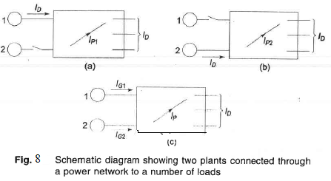

MP1 and MP2 are called ***current distribution factors.***The values of current distribution factors depend upon the impedances of the lines and their interconnection and are independent of the current ID*.*

When both generators 1 and 2 are supplying current into the network as in Fig. 8(c), applying the principle of superposition the current in the line *p* can be expressed as



where IG1 and IG2 are the currents supplied by plants 1 and 2, respectively. At this stage let us make certain simplifying assumptions outlined below:

1.All load currents have the same phase angle with respect to a common To understand the implication of this assumption consider the load current at the ith bus

2. Ratio ***X/R***is the same for all network branches.

These two assumptions lead us to the conclusion that IP1 and ID [Fig. 8(a)] have the same phase angle and so have IP2 and ID [Fig. 8(b)], such that the current distribution factors MP1 and MP2 are real rather than complex.

Let,  [Derivation of Transmission Loss Formula](http://www.eeeguide.com/wp-content/uploads/2016/12/Derivation-of-Transmission-Loss-Formula-4.jpg)

where σ1 and σ2 are phase angles of IG1 and IG2, respectively with respect to the common reference.



From Eq. (1.29), we can write







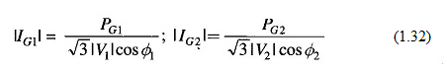

where PG1 and PG2 are the three-phase real power outputs of plants 1 and 2 at power factors of cos Φ1, and cos Φ2, and V1 and V2 are the bus voltages at the plants.

If RP is the [resistance](http://www.eeeguide.com/resistance/) of branch *p,* the total transmission loss is given by*



Substituting for |IP|2 from Eq. (1.31), and |IG1| and |IG2| from Eq. (1.32), we obtain

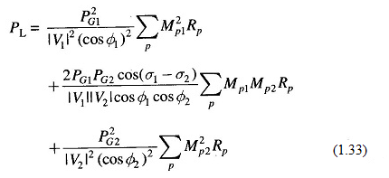

Equation (1.33) can be recognized as

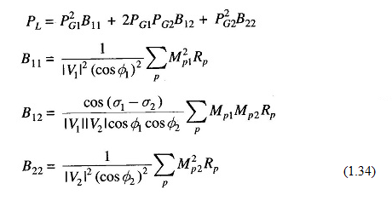

The terms B11, B12 and B22 are called ***loss coefficients* or *B–coefficients****.* If voltages are line to line kV with resistances in ohms, the units of B-coefficients are in MW-1. Further, with PG1 and PG2 expressed in MW, *PL* will also be in MW.

The above results can be extended to the general case of *k* plants with transmission loss expressed as



Where

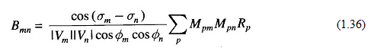

The following assumptions including those mentioned already are necessary, if B-coefficients are to be treated as constants as total load and load sharing between plants vary. These assumptions are:

1. All load currents maintain a constant ratio to the total current.
2. [Voltage magnitudes](http://www.eeeonline.org) at all plants remain constant.
3. Ratio of reactive to real power, i.e. power factor at each plant remains
4. Voltage phase angles at plant buses remain fixed. This is equivalent to assuming that the plant currents maintain constant phase angle with respect to the common reference, since source power factors are assumed constant as per assumption 3 above.

In spite of the number of assumptions made, it is fortunate that treating *B-*coefficients as constants, yields reasonably accurate results, when the coeffi­cients are calculated for some average operating conditions. Major system changes require recalculation of the coefficients.

Losses as a function of plant outputs can be expressed by other methods*, but the simplicity of loss equations is the chief advantage of the B-coefficients method.

Accounting for transmission losses results in considerable operating economy. Furthermore, this consideration is equally important in future system planning and, in particular, with regard to the location of plants and building of new transmission lines: